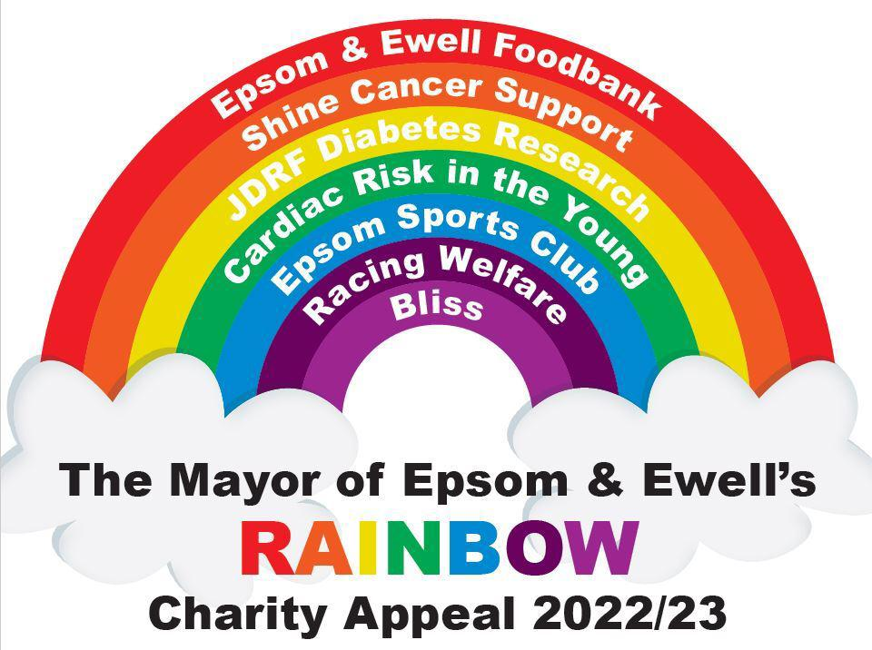
Epsom Charity Café Bridge
Tuesday 28th March 2023
Registration 09.30hrs. Play starts 10.30hrs. Results 16.00hrs
Detailed instructions will be sent nearer the event
£70 pair including 2 course lunch
Refunds will be given for cancellations before 14th March 2023
Player 1 - Name ………………………………………………..………… Tel …………………………..
Email ………………………………………………………………………………
Dietary requirements …………………………………………………….
Player 2 - Name …………………………………..……………………… Tel …………………………..
Email ………………………………………………………………………………
Dietary requirements …………………………………………………….
Café’s include Pizzerium, Ask Italian, Koza, Epsom Social and Epsom Club
Y / N
One of us has a smart phone and are willing to score -

Please return this form by post, email or in person to
Neil Dallen 13 Epsom Court, Epsom KT17 4ER neildallen@hotmail.co.uk
Cheque enclosed to Clive Woodbridge Mayors Charity Account
BACS to Sort 20-57-76 Account 13688038 Ref “Bridge – your name”

