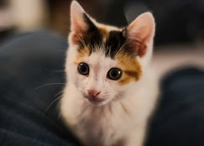

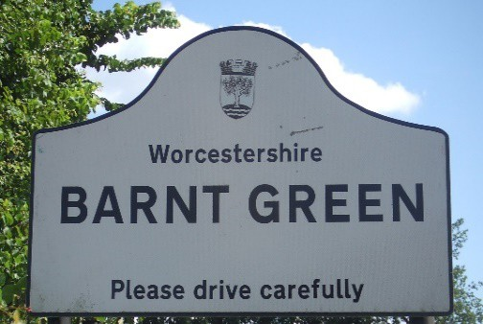

♥ ♣ 5th Annual Barnt Green Café Bridge ♦ ♠

You are invited to a Charity Duplicate Bridge event, sponsored by The Garrity,

in aid of the Bromsgrove Blue Cross Rehoming Centre on

**Thursday 12th October 2023**

**Entry fee of £35.00 per player incl. coffee/tea at your starting venue, lunch at one of the venues and a glass of Prosecco at the end, plus PRIZES!**

**Bromsgrove Bridge Club is pleased to be the coordinator of the event and welcomes players from all over the country to participate, including all clubs local to Barnt Green & Worcestershire.**

**LAST TIME THIS EVENT RAISED £1,000 FOR CHARITY – WE HOPE TO DO EVEN BETTER THIS YEAR!**

**How Does Café Bridge Work?**

* You play a few hands in one café then move to another. You get lunch wherever you are at lunchtime.
* If you are disabled and would like to stay in one location all day, please let us know in advance.
* Registration will be at **The Garrity** at 10.40 a.m., and the play will start promptly at 11.00 a.m.
* You choose where you would prefer to lunch on a first-come basis when you send your entry.
* Play a few hands, walk to the next venue, and play again, and so on playing up to 30 boards in the day.
* Lunch is included, and extra refreshments will be available for purchase at each venue.

Please support the venues by buying drinks throughout the day.

* On completion we meet at **The Garrity** for convivial complimentary drinks, a postmortem of the day and a raffle; results and prize giving (prizes for the top two pairs) will be at around 4.30 p.m.

**Thanks to our sponsors and to our partner organisations and Raffle Prize Sponsors:**

|  |  |  |  |
| --- | --- | --- | --- |
| **The Barnt Green Inn** | **Café Morso**  Morso shop | **The Garrity**  Photo | **The Victoria Inn**  2 |



|  |  |  |  |  |
| --- | --- | --- | --- | --- |
|  |  |  |  | Oasis Flowers & Balloons - Logo_Page_1 |
| Its a Gift |  |  |  |  |

♥ ♣ **5th Annual** **Barnt Green Café Bridge** ♦ ♠

**Where would you prefer to have lunch? – please indicate order of preference in left box using 1st to 4th – sorry cannot guarantee your 1st choice – first come first served. Also tick menu choices at each venue.**



**Please enter the following pair in this event (Deadline date October 1st):**

**Player 1**: Name……………………………………………………………………………………………………………..................

Contact details/phone/email ……………………………………………………………………………………………………….

**Player 2**: Name ……………………………………………………………………………………………………………………………

Contact details/phone/email ………………………………………………………………………………………………………

I enclose a cheque made payable to “Bromsgrove Bridge Club” for **£70**

Please send this form and your cheque to Richard Jephcott at 6, Pinfield Drive, Barnt Green, Birmingham, B45 8XA

Email: [***Richardjephcott@me.com***](mailto:Richardjephcott@me.com)or phone 0121 291 2589 or 0781388509 with any questions.

**Copies of this form are available from Richard Jephcott at the above email address and at**

[**http://www.bridgewebs.com/worcestershire/**](http://www.bridgewebs.com/worcestershire/) **&** [**http://www.bridgewebs.com/bromsgrove/**](http://www.bridgewebs.com/bromsgrove/)